GREENHOUSE GAS INVENTORY REPORT
Inventory years 2019 & 2020

FEBRUARY 2022

EXECUTIVE SUMMARY

The climate crisis is one of the defining challenges of our time, and it is already having significant impacts on communities globally. Rising temperatures are driving increases in extreme and hazardous weather, natural disasters, food and water insecurity, environmental degradation, sea level rise, economic disruptions, migrations, and conflict. Illinois is not immune to these risks, and the cost of unmitigated climate change will be high. Addressing and preparing for climate change is essential for NIU to continue to be able to fulfill its mission as a leader in education and research.
Greenhouse gas inventories are tools used to quantify annual emissions, and to serve as a baseline against which future reduction efforts can be measured. This report summarizes the results of NIU’s first ever greenhouse gas inventories, with results for the years 2019 and 2020. These years were chosen as the most recent years for which complete data was available; 2019 represents a year with ‘normal’ operations and 2020 represents a point of comparison for emissions under reduced operations. The inventory calculations were completed using ICLEI’s Clearpath tool.
In both 2019 and 2020, the greatest sources of carbon emissions were from purchased energy (electricity and natural gas) and transportation related to commuting. Unsurprisingly, commuting contributed significantly fewer emissions in 2020 compared to 2019. Emissions from buildings (electricity and natural gas) fell relatively little in 2020, despite the significant reductions in campus operations. The 2019 and 2020 inventories now serve as a baseline from which NIU can engage in climate action planning, with the goal of significantly reducing total emissions in the near future.
All efforts to address climate change must acknowledge the uneven ways in which climate change will be felt, as socially and economically disadvantaged communities are at greater risk, including many of the communities our students come from. Environmental justice has been identified as a top research and teaching priority at NIU. As we begin conversations around climate change mitigation and adaptation, we should leverage our institutional knowledge of diversity, equity and inclusions programs to prioritize integrate social and environmental justice into all our plans.
We strongly recommend that NIU join the President’s Climate Leadership Network and become a signatory to Second Nature’s carbon commitment. This would formally commit NIU to a goal of carbon neutrality by a specific date. We also recommend that NIU undertake a formal process of climate action planning, involving stakeholders across campus to find ways to mitigate climate change through emissions reductions and to improve the resilience of our campus by planning for future disruptions associated with climate change. We provide specific recommendations and a timeline for the process of climate action planning, and highlight the opportunities to involve students and faculty in this process by using campus as a living laboratory. Finally, we provide recommendations for improving the process of completing future greenhouse gas inventories at NIU.

Table of Contents
I. Glossary 4
II. Introduction 5
III. Scope of the Inventory 6
Boundaries 6
Scope of Emissions 6
Scope 1: Direct emissions 6
Scope 2: Indirect emissions (upstream) 6
Scope 3: Indirect emissions (downstream) 6
Global Warming Potentials 7
Data sources 8
Assumptions in Inventory Calculations 8
Student commutes 8
Faculty and staff commutes 9
Clearpath Inventory Tool 9
IV. Results 10
Emissions by sector in 2019 10
Emissions by Scope 11
2019 11
2020 12
Comparing 2019 to 2020 13
Comparing emissions from NIU and other institutions 14
V. Scientific and Policy Context 14
Urgency of Net Zero 14
Climate Commitments by the State of Illinois 15
Climate and Environmental Justice 15
VI. Recommendations 16
Establish a Formal Climate Commitment 16
Climate Action Planning 18
Campus as a Living Laboratory 19
Future greenhouse gas inventories 21
Include additional Scope 3 data 21
Transportation survey 21
Frequency of Future Inventories 22
Streamline data collection process 22
Choice of inventory tool 22
VII. Acknowledgements 22
VIII. Appendices 23
Appendix A. Global Warming Potential (GWP) values for IPCC’s 5th assessment 23
Appendix B. Climate Commitments made by peer and regional institutions 24
Appendix C. Examples of climate action planning initiatives at other universities 25
IX. Bibliography 26

Glossary

Carbon Dioxide Equivalent (CO₂e)
A metric used to compare emissions of various greenhouse gases. It is the mass of carbon dioxide that would produce the same estimated radiative forcing as a given mass of another greenhouse gas. Carbon dioxide equivalents are computed by multiplying the mass of the gas emitted by its global warming potential.

Emission Inventory
An estimate of the amount of pollutants emitted into the atmosphere from various sectors over a specific period of time such as a day or a year.

Global Warming Potential (GWP)
Represents the relative warming effect of a unit mass of a greenhouse gas compared with the same mass of CO₂ over a specific period. Multiplying the actual amount of gas emitted by the GWP gives the CO₂-equivalent emissions

IPCC
The Intergovernmental Panel on Climate Change (IPCC) is the United Nations body for assessing the science related to climate change.

Paris Climate Agreement
The Paris Agreement is a legally binding international treaty on climate change whose goal is to limit global warming to well below 2, preferably to 1.5 degrees Celsius, compared to pre-industrial levels. The United States is a signatory to this treaty.

President’s Climate Leadership Network
The Climate Leadership Network is a signature program of the climate action organization Second Nature that provides resources, networking, and national engagement opportunities for signatory institutions. Members of the climate leadership network formalize commitments to the goal of carbon neutrality via carbon, climate, or resilience commitments.

Second Nature
A climate action and advocacy organization that is committed to accelerating climate action in, and through, higher education. They work primarily with leadership in higher education through the Climate Leadership Network and the University Climate Change Coalition.

UNFCC
The UNFCCC is the United Nations Framework Convention on Climate Change, a treaty now signed by 197 countries. Under this convention, signatories agree to stabilize greenhouse gas concentrations “at a level that would prevent dangerous anthropogenic (human induced) interference with the climate system.”

US Climate Alliance
An organization representing U.S. states that are committed to taking action that addresses the climate challenge. Member states commit to achieve the Paris Agreement’s goal of keeping temperature increases below 1.5 degrees Celsius. Illinois is a signatory to the U.S. Climate Alliance.

Introduction

The climate crisis is one of the most urgent challenges we currently face. Climate change is already having vast negative global consequences, including increased extreme weather events, increased forest fires, food and water scarcity, increased spread of disease, and so much more. Projected changes in temperature extremes are predicted to be larger in frequency and intensity with every additional increment of global warming, resulting in greater human and environmental impacts. The most recent report of the Intergovernmental Panel on Climate Change (IPCC) is clear that that while some of the changes caused by climate change are irreversible over hundreds to thousands of years, strong and sustained reductions in CO₂emissions and other greenhouse gases would limit climate change and make adaptation to future changes more feasible (IPCC, 2021).

Illinois is predicted to experience significant long-term changes in weather patterns with major impacts on the health and well-being people in our region. Increasing temperatures will lead to more variable rainfall with increased droughts and extreme flooding, more intense rain and winter storm events, more extreme heat and cold events, reductions in agricultural yields, and significant health impacts for the residents of Illinois, with the consequences disproportionately impacting communities with already high rates of chronic disease, inadequate resources, and exposure to other environmental health hazards. The economic impacts of unmitigated climate change will likely be immense for our region (Wuebbles et al, 2021).

NIU’s mission—to empower students through educational excellence and experiential learning as we pursue knowledge, share our research and artistry, and engage communities for the benefit of the region, state, nation, and world—is deeply at risk in a future of unmitigated climate change. The physical, social, political, and economic consequences of climate change will affect every aspect of our university operations. Preparing for climate change is essential for NIU to continue to be able to fulfill its mission as a leader in education and research. NIU can also serve as a leader in our community by demonstrating effective ways to reduce greenhouse gas (GHG) emissions and adopting adaptive measures to protect our future. Greenhouse gas inventories are essential tools in the climate change mitigation process; by quantifying emissions they serve as a baseline against which to measure future reduction efforts. This report details the results of Northern Illinois University’s first GHG inventory for the calendar years 2019 and 2020 and provides recommendations for climate action planning moving forward.

There are four stages to the GHG inventory process: 1) inventory planning, 2) data collection and GHG emissions calculations, 3) data analysis for climate action planning, and 4) setting GHG emissions reduction targets and tracking future progress (Ranganathan et al., 2004).
Step 1: Data Collection – Collection of raw data required to conduct a GHG inventory, including purchased electricity and natural gas, transportation modes and distances, solid waste and wastewater generated. This can also include emissions related to purchased goods and services and investments.
Step 2: Emissions Calculations – Collected data is processed as inputs into a calculator tool. NIU used the ICLEI Clearpath tool, which calculates annual emissions using the IPCC 5th assessment’s protocol.
Step 3: Data Analysis – In order to compare GHG sources and identify emissions reduction opportunities, Clearpath converts all emissions into CO2 equivalents based on the global warming potential (GWP) of each greenhouse gas.
Step 4: Climate Action Planning --Data from NIU’s GHG inventories can now be used for climate action planning, including setting specific reduction targets for the different scopes of the inventory.
This report begins by covering the scope of the inventory, including study boundaries. Results of the inventory are presented under each category, together with assumptions made during calculations. Discussion of results is followed by recommendations for updating this report in the future. We conclude by providing recommendations for how to use this report for climate action planning at NIU.

Scope of the Inventory

Boundaries

This greenhouse gas inventory includes emissions generated by NIU’s main campus in DeKalb, IL. The calendar years of 2019 and 2020 were selected to provide a preliminary point of comparison between a year of typical operations and a year of reduced operations. The year 2019 was the most recent year during which time NIU was fully operational with most teaching, research and other activities happening in person. In contrast, the year 2020 marked the start of the covid-19 pandemic and the ensuing closure of most campus operations, which only partially resumed during the second half of the year.

Scope of Emissions

The GHG Protocol Corporate Standard classifies an organization’s GHG emissions into three ‘scopes’. Scope 1 emissions are direct emissions from owned or controlled sources. Scope 2 emissions are indirect emissions from the generation of purchased energy. Scope 3 emissions are all indirect emissions (not included in scope 2) that occur in the value chain of the reporting company, including both upstream and downstream emissions.”

Scope 1: Direct emissions
Includes any emissions directly generated by the university from fuel combustion. As NIU does not operate a power generation plant, only emissions from NIU’s campus boilers and vehicle fleets are included in Scope 1.

Scope 2: Indirect emissions (upstream)
This includes indirect emissions from the generation of purchased energy from a utility provider for steam, heat and cooling. At NIU this included the purchase of electricity and natural gas.

Scope 3: Indirect emissions (downstream)
This includes all other emissions that occur in a university’s value chain. At NIU, we included emissions from water and wastewater treatment, solid waste facilities, student and employee commutes, study abroad travel, and any athletics travel that took place using university fleet vehicles. Scope 3 emissions can also include faculty and student travel (e.g. conferences, research), athletics travel via outside vendors, purchased goods and services, and financial investments. These sources of emissions were excluded from the 2019 and 2020 greenhouse gas inventories as the data was not feasible to collect at this point in time.
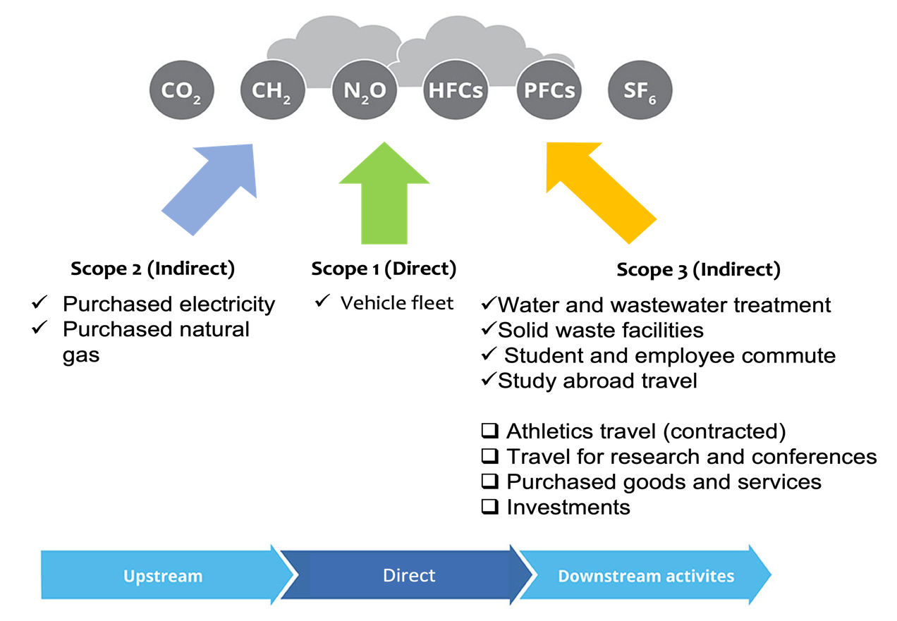

Global Warming Potentials

Greenhouse gases vary in their residence time in the atmosphere and how effective they are at blocking heat escaping from the earth-atmosphere system and thus warming it (Gillenwater, 2015). Because of these differences, the global warming potential (GWP) variable was created as a standardized unit of measurement for greenhouse gases and their impacts. These various greenhouse gas emissions are transformed using their global warming potential values (GWPs) into carbon dioxide equivalents (CO₂e) so that they can be standardized to create one CO₂e value for a process. The GWP of different greenhouse gases is determined based on the current scientific consensus reported in the IPCC assessment reports. This GHG inventory was conducted using the 100 year GWP values from the IPCC’s 5th assessment (Appendix A).

Data sources

Data was obtained from a variety of sources on campus and in the community.

Sector | Data type | Source | Contact Person
Employee commute | Zip codes for local addresses of students, faculty, and staff. | Human Resources  Registration and Records | Alan Clay (HR)  Lisa Anderson (R&R)
Purchased electricity and natural gas | Total electricity and natural gas usage | Architecture and Engineering Services | Jim Fitzjarrell
Study abroad | Flight itineraries were used to calculate total miles traveled. | Study Abroad Office | Lauren Mock
Transit Fleet | Total annual milage for Huskie Bus Line, fuel type, and percent of student ridership. | City of DeKalb Transit Fleet Manager | Marcus Cox
University fleet | Total vehicle milage and fuel type for all NIU fleet vehicles. | Transportation Services | Laura Lundelius  Chris Gilbert
Waste | Tons of waste that is generated from NIU | Waste Management in DeKalb | Daniel Flores
Water and Wastewater Treatment | Emissions from digester gas and discharge from the process of wastewater treatment. | Kishwaukee Water Reclamation District | Mike Holland

Assumptions in Inventory Calculations

Assumptions were made when compiling the inventory data, particularly regarding emissions from student and employee commuting. University GHG inventories typically estimate commuting data in one of two ways; 1) conducting a transportation study that surveys students, faculty and staff about their commuting behaviors, and 2) using zip code data from student, faculty and staff places of residence to estimate total miles traveled. We were advised by our ICLEI Clearpath contact that a transportation study is challenging to conduct, and that most universities rely on zip code data the first time they carry out an inventory. Thus, this is the route we chose.

Student commutes
Registration and records provided us with zip code data for all NIU students by semester of attendance. Many students had zip codes more than 60 miles from NIU. R&R confirmed this was likely a permanent address (e.g. their parent’s house) and their local address was plausibly near DeKalb. Thus, all students with zip codes more than 60 miles from DeKalb were assigned the 60115 zip code.

In 2019, we assumed that students commuted on average 4 times per week during fall, spring and summer semesters for which they were enrolled.

In 2020, because of the impacts of covid-19, we made the following assumptions:
- Students commuted 4x/week during the first half of Spring 2020 (Jan-March)
- No students commuted to campus during Summer 2020
- 10% of students commuted to campus 2 times per week during fall. This assumption was based on information that approximately 10% of classes were held in person during Fall 2020 semester.

Faculty and staff commutes
Human resources provided us with the zip codes for all NIU employees. Employees with zip codes more than 60 miles from NIU were assumed to be full-time remote employees. For employees with 12-month appointments, we assumed a 250 day work year and for 9 month appointments we assumed 200 working days per year. We acknowledge that most employees with 9-month appointments work over the summer but are less likely to be commuting to campus while off contract.

In 2019, we assumed that most employees commuted to campus 5 days per week.

In 2020, because of the impacts of the covid-19 pandemic, we made the following assumptions:
- Employees commuted normally (5 days per week) until March 13, 2020
- From March 15 to May 15 there were almost no employees commuting to campus
- From May to August 2020, 5% of employees commuted daily over the summer
- Fall semester 2020, 10% of employees commuted to campus daily

We acknowledge these assumptions are imperfect but were our best attempt at capturing the complexity of the pandemic situation.

Clearpath Inventory Tool
Data about inventory processes (e.g. electricity consumption) are fed into inventory tools to calculate total CO₂e emissions. This inventory was completed using ICLEI’s Clearpath tool. This choice was made based on prior experience with the Clearpath tool, its reputation as a leader in sustainability and climate action, and excellent customer support which was helpful when deciding how to handle nuanced situations that resulted from unusual operations during the pandemic. Clearpath models are regularly updated with the most current science from the IPCC. Emissions outputs can be adjusted based on the choice of global warming potentials for different IPCC assessments. Detailed records have been maintained inside the Clearpath tool to facilitate future greenhouse gas inventories for NIU.

Results

Emissions by sector in 2019

NIU emitted a total of 123,297 metric tons of CO₂e in 2019. Energy consumption was the largest source of emissions, followed by transportation.

Emissions by Sector
Sector | CO₂e Emissions in Metric Tons | Percent Contribution to Inventory Total
Energy | 80,671 | 65.4%
Transportation | 37,834 | 30.7%
Solid Waste | 4,326 | 3.5%
Water and Wastewater | 464 | 0.4%
Total | 123,297 | 100

Emissions by sector in 2020

NIU emitted a total of 86,585 metric tons of CO₂e in 2020. NIU emitted a total of 123,297 metric tons of CO₂e in 2019. Energy consumption was the largest source of emissions, followed by transportation. Transportation related emissions were significantly lower in 2020 due to the impacts of the covid-19 pandemic, and reductions in fleet vehicle usage and commuting to campus.

Emissions by Sector
Sector | CO₂e Emissions in Metric Tons | Percent Contribution to Inventory Total
Energy | 72,267 | 83.5%
Transportation | 10,103 | 11.7%
Solid Waste | 3,751 | 4.3%
Water and Wastewater | 464 | 0.5%
Total | 86,585 | 100

Emissions by Scope

2019
A detailed list of emissions by scope and process is provided for 2019. The largest sources of emissions come from boilers (Scope 1), grid electricity usage (Scope 2), and student commuting (Scope 3).

Emissions Processes with Calculated CO₂e and % Contribution to Total
2019
 | Emission process | Calculated CO2e Emissions (MT) | % Contribution to Total Emissions
Scope 1 | Emissions from Flaring of Digester Gas | 124.5 | 0.1
 | Emissions from Combustion of Digester Gas | 2.8 | 0.0
 | N2O Emissions from Wastewater Treatment | 104.3 | 0.1
 | Process N2O from Effluent Discharge to Rivers and Estuaries | 232.5 | 0.2
 | Boiler Emission data | 33568.0 | 27.2
 | Stationary Fuel Combustion- without boilers | 1219.4 | 1.0
 | Emission from Generators - Gasoline | 41.7 | 0.0
 | Emission from Generators - Diesel | 16.2 | 0.0
 | Emissions from landfill gas | 3490.2 | 2.8
 | NIU Huskie line | 1521.5 | 1.2
 | Diesel Vehicles | 140.2 | 0.1
 | Gasoline+ Hybrid Vehicles | 680.7 | 0.6
 | Ethanol85 record | 0.0 | 0.0
 | Unleaded with ethanol 10 record | 4.0 | 0.0
 | Unleaded with ethanol 77 record | 0.1 | 0.0
Scope 2 | Electricity loss from loss factor | 2181.9 | 1.8
 | Grid Electricity Usage | 43638.0 | 35.4
 | Grid Electricity Usage (streetlight) | 6.0 | 0.0
 | Electric Vehicles | 0.0 | 0.0
Scope 3 | Solid Waste emission | 836.6 | 0.7
 | Study Abroad Emission | 500.7 | 0.4
 | Student commute | 26199.0 | 21.2
 | Staff commute | 8789.2 | 7.1
Total |  | 123,297.5 | 100.0

2020
A detailed list of emissions by scope and process is provided for 2019. Similar to 2019, the largest sources of emissions come from boilers (Scope 1) and grid electricity usage (Scope 2). Emissions from student and staff commuting (Scope 3) contributed far less to total emission in 2020 than in 2019.

Full list of Emissions Processes with Calculated CO₂e and % Contribution to Total
2020

 | Emission process | Calculated CO2e Emissions (MT) | % Contribution to Total Emissions
Scope 1 | Emissions from Flaring of Digester Gas | 124.5 | 0.1
 | Emissions from Combustion of Digester Gas | 2.8 | 0.0
 | N2O Emissions from Wastewater Treatment | 104.3 | 0.1
 | Process N2O from Effluent Discharge to Rivers and Estuaries | 232.5 | 0.3
 | Boiler Emission data | 31,147 | 36.3
 | Stationary Fuel Combustion- without boilers | 1151.7 | 1.3
 | Emission from Generators - Gasoline | 17.5 | 0.0
 | Emission from Generators - Diesel | 3.7 | 0.0
 | Emissions from landfill gas | 3,172 | 3.7
 | NIU Huskie line- Diesel | 1,232 | 1.4
 | NIU Huskie line- Gasoline | 144.8 | 0.2
 | Diesel Vehicles | 55.9 | 0.1
 | Gasoline+ Hybrid Vehicles | 436.9 | 0.5
 | Unleaded with ethanol 10 record | 0.8 | 0.0
 | Unleaded with ethanol 57 record | 0.02 | 0.0
Scope 2 | Grid Electricity Usage | 39,697 | 46.3
 | Grid Electricity Usage (streetlight) | 6 | 0.0
Scope 3 | Study Abroad Emission | 38.7 | 0.0
 | Student commute | 5,560.20 | 6.5
 | Staff commute | 2,635 | 3.1
Total |  | 85,763.32 | 100.0

Comparing 2019 to 2020

Total emissions were lower in 2020 than in 2019, which is expected given the partial closure of NIU’s campus during 2020 as a result of the covid-19 pandemic.

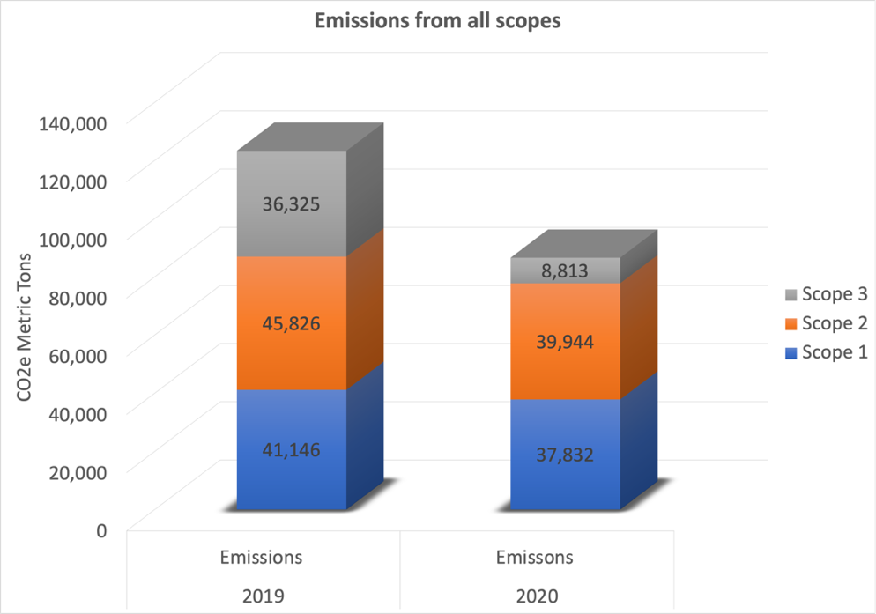

Greenhouse gas emissions fell by 17.4% from 2019 to 2020. This is largely attributable to reductions in emissions from NIU’s vehicle fleet and employee and student commuting during the second half of 2020 as a result of the covid-19 pandemic. There were minimal reductions in emissions tied to buildings and facilities (from electricity and natural gas) and in solid waste facilities. These results are in line with studies of emissions reductions nationally due to the pandemic, with the largest reductions occurring as a result of reduced travel (Le Quéré et al., 2020). It is important to note that in 2021 greenhouse gas emissions globally have returned to pre-pandemic levels and continue to rise. We expect that a 2021 greenhouse gas inventory for NIU would show emissions levels similar to 2019.

Energy consumption by buildings and facilities fell by only 5.5%, despite far less intensive use of the campus by students during 2020. This suggests that more deliberate and significant changes need to be made as part of climate action planning in order to meet decarbonization goals.

​Sector | ​2019 | 2020​ | % Change​
Buildings & Facilities​ | 80,665​ | 72,261​ | -5.5​
Street Lights & Traffic Signals​ | 6​ | 6​ | 0.0​
Vehicle Fleet​ | 825​ | 493​ | -25.2​
Transit Fleet​ | 1,521​ | 1,377​ | -5.0​
Employee Commute​ | 35,488​ | 8,233​ | -62.3​
Solid Waste Facilities​ | 4,326​ | 3,752​ | -7.1​
Water & Wastewater Treatment Facilities​ | 464​ | 464​ | 0.0​
Total | 123,297 | 86,589 | -17.4

Comparing emissions from NIU and other institutions

To provide some perspective, we benchmarked NIU’s emissions relative to other Midwestern universities in Illinois, Michigan and Wisconsin (all of which have similar climates). This data is based on publicly available data, so comparisons by year were not always possible. Emissions were standardized per capita based on the student population at the time of the inventory. As evident in the table below, NIU’s per capita emissions are relatively low compared to the benchmarked universities. However, many of these institutions include Scope 3 emissions that were not included in the NIU inventories such as faculty and staff travel to conferences and research, purchased goods and services, and indirect emissions tied to financial investments. Internal comparisons of how NIU’s emissions change over time will be more valuable to understanding our efforts towards climate mitigation rather than comparisons to peer institutions. This can be accomplished by regularly conducting greenhouse gas inventories at NIU.

Institution | Total CO₂e Emissions  (MT) | Year | Student Population | Per capita emissions (MT)
University of Wisconsin-Milwaukee | 107,377 | 2019 | 19,829 | 5
Northern Illinois University (2020) | 86,589 | 2020 | 16,769 | 5.1
Northern Illinois University (2019) | 123,297 | 2019 | 16,609 | 7.4
University of Illinois Urbana Champaign | 433,797 | 2019 | 51,605 | 8
Michigan State University | 423,765 | 2016 | 47,131 | 9
University of Illinois Chicago | 275,000 | 2008 | 27,875 | 10
University of Michigan | 593,000 | 2020 | 47,907 | 12
University of Wisconsin-Madison | 567,096 | 2020 | 45,537 | 12

Scientific and Policy Context

Urgency of Net Zero

The Paris Climate Agreement, a legally binding international treaty to which the United States is a signatory, established the goal of limiting global warming to well below 2, preferably to 1.5 degrees Celsius, compared to pre-industrial levels. Just three years after the Paris Agreement, the Intergovernmental Panel on Climate Change (IPCC) released a ‘code red’ special report arguing that we need to prevent the planet from warming above 1.5°C in order to avert catastrophic damage to the planet. This will require net emissions to fall by about 45% from 2010 levels by 2030, reaching ‘net zero’ around 2050 (IPCC, 2018).

The race to net zero has become a call to action for local, regional, and national governments and institutions, including numerous institutions of higher education. Carbon budgets—the total amount of carbon that can be emitted before reaching 1.5°C— have been an important tool for framing policy around emissions reductions needed to get us to net zero. Although there is great uncertainty in the total carbon budget remaining, nearly all models agree that we have less than 10 years to take drastic action towards reducing emissions to meet the 1.5°C goal, and only 30 years to reach net zero to keep warming below 2°C. However, ahead of the most recent United Nations Conference of Parties meeting (COP27), the world was still on track for 2.7°C warming. This poses an unacceptable level of risk to societies around the world, including in Illinois.

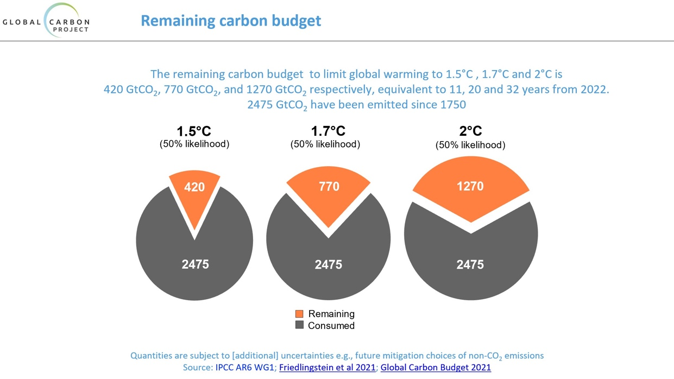

Climate Commitments by the State of Illinois

Illinois has become a national leader in terms of climate action at the state level. In 2019, via Executive Order 2019-06, Illinois joined the US Climate Alliance, a group of states committed to reducing greenhouse gas (GHG) emissions consistent with the Paris Agreement. In September 2021, Illinois passed the Climate and Equitable Jobs Act (SB2408), which will require Illinois to achieve 100% net zero emissions in the power sector by 2045 and invest in renewable energy generation, energy efficiency, and jobs creation. Of particular note is the strong focus of the bill on environmental justice, and a “just transition” that prioritizes the needs of low-income communities and communities of color throughout the state. Illinois is the first Midwestern state to pass this type of comprehensive climate legislation.

The Climate and Equitable Jobs Act will provide significant funding through grants and subsidies for clean energy transitions, and NIU will be well poised to take advantage of these opportunities if we are strategic and make concerted efforts towards climate action sooner rather than later.

Climate and Environmental Justice

While climate change is a threat to everyone, some communities face greater risks. The geography of socially and economically disadvantaged communities in the United States puts these communities, often communities of color, at far greater risk because of where they live, their access to resources, health status, and exposure to other environmental risks. Extreme weather events, heat waves, poor air quality, and pollution will all disproportionately affect these disadvantaged communities. The future impacts of climate change cannot be separated from our country’s history of racism, classism, and sexism—climate change is an intersectional issue, and actions to mitigate and adapt must be approached through the framework of environmental justice.

Equity and inclusion are central to NIU’s mission, and we should feel proud of our strong diversity, equity and inclusion programs that demonstrate our strong commitment to the success of our students who come from diverse communities and socioeconomic backgrounds. Recently President Freeman recognized the importance of connecting social and environmental justice at NIU, by prioritizing environmental justice as one of NIU’s research and teaching priorities in 2022. A significant number of our students come communities in Illinois that have a long history of environmental injustices, and that are already being adversely affected by changing weather patterns tied to anthropogenic climate change. When NIU commits to addressing climate change by reducing greenhouse gas emissions, we demonstrate our commitment to social and environmental justice, and we prioritize the future of our students and the communities we serve.

Recommendations

Establish a Formal Climate Commitment

NIU can demonstrate its strong commitment to social and environmental justice by creating specific and actional plans towards decarbonization. Given the IPCC’s urgent call to action for ‘net zero by 2050’, we recommend a goal for NIU that aligns with this timeframe. NIU should mark its 150th anniversary by committing to carbon neutrality by the year 2045.

In 2014, NIU signed the American College & University President’s Climate Commitment (ACUPCC), but our commitment has since lapsed. As of 2015, the ACUPCC commitments are now part of the organization Second Nature, which expanded to form the President’s Climate Leadership Commitments. There are now three commitments that institutions can sign:
- Carbon Commitment- focused on reducing greenhouse gas emissions and achieving carbon neutrality as soon as possible
- Resilience Commitment- focused on climate adaptation and building community capacity
- Climate Commitment- integrates carbon neutrality with climate resilience, and provides a systems approach to mitigating and adapting to a changing climate

We strongly recommend that NIU join the President’s Climate Leadership Network and sign the Second Nature Carbon Commitment, which would publicly commit NIU to a goal of carbon neutrality. The Carbon Commitment is a good first step towards the more comprehensive planning, present in the climate commitment, that NIU will eventually need to work towards. Becoming a signatory of Second Nature’s Carbon Commitment also offers numerous benefits in terms of resources, networking and national engagement opportunities that help institutions with climate action planning to meet their institutional goals.

Many institutions of higher education in Illinois have already made formal climate agreements.

Institution | Climate Leadership Network  Membership Type | Race to Zero Member | Carbon Neutral Date
University of Illinois Chicago (UIC) | Climate | Yes | 2050
University of Illinois Urbana Champaign (UIUC) | Climate | Yes | 2050, or sooner
Loyola University | Carbon | Yes | 2025 (Scope 1 and 2 only)
School of the Art Institute of Chicago | Climate | No | 2060
Southern Illinois University Carbondale (SIU) | Climate | No | Not available
Lewis and Clark Community College | Carbon | No | 2058
Illinois College | Carbon | No | Not available
University of Illinois at Springfield | Carbon | No | Not available
Parkland college | Carbon | No | 2060

Appendix B provides the names of peer institutions and schools throughout the Midwest that have signed climate agreements.

Several institutions have also signed the UNFCC’s Race to Zero pledge, which requires institutions to halve their CO₂e emissions by the year 2030. This is because the scientific consensus (citations) is that emissions reductions must be frontloaded if we are to avert the worst effects of climate change. While NIU may or may not be positioned to halve our emissions by 2030, it is imperative we strive towards this goal in our own climate action planning.

This map, created by Second Nature, shows the widespread extent of carbon, climate, and resilience commitments in the United States.
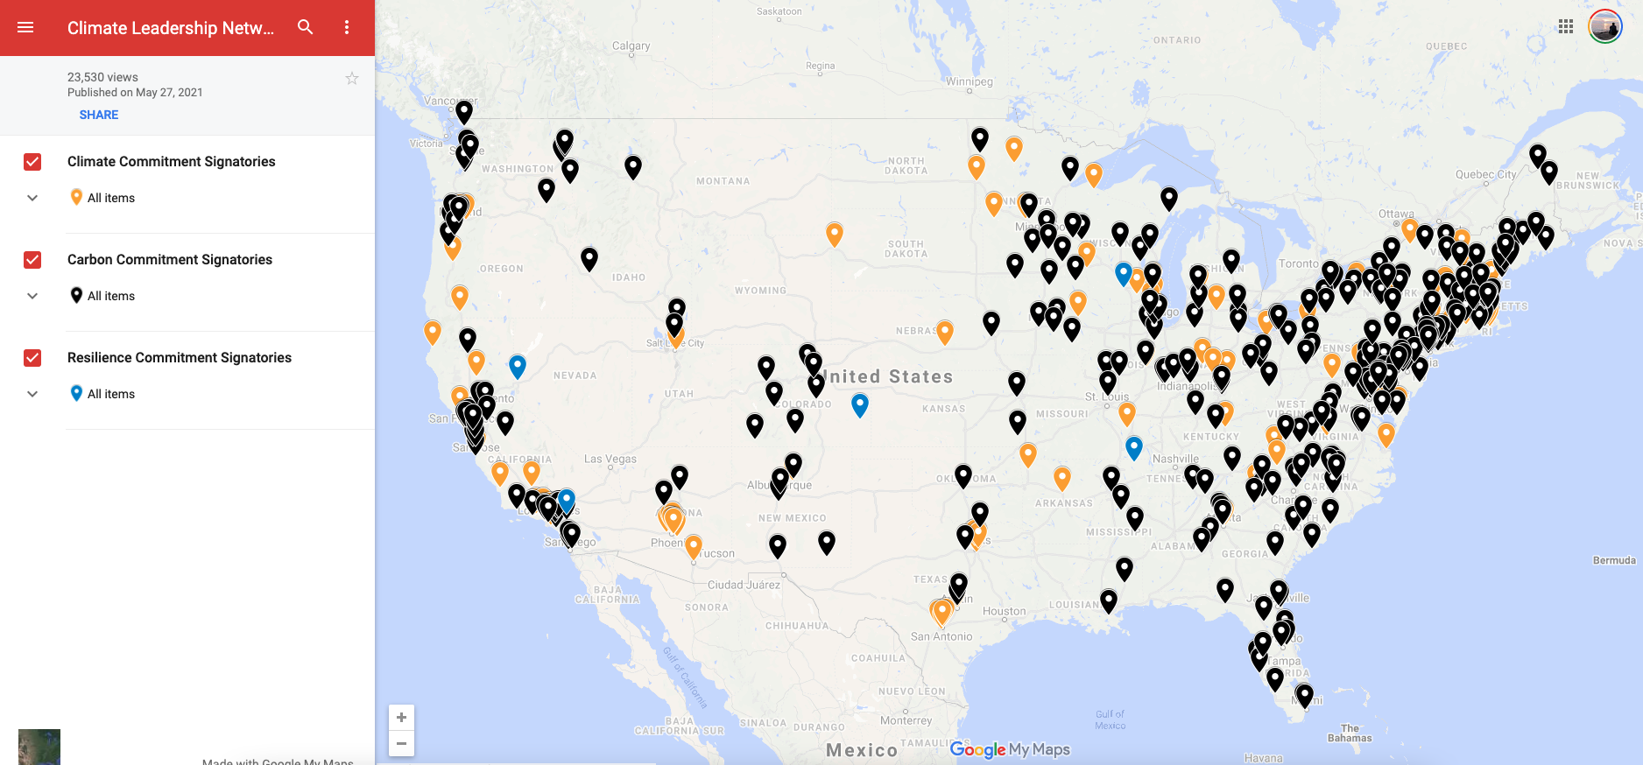

Climate Action Planning

With the completion of the 2019 and 2020 GHG inventories, NIU is now well positioned to draft our first climate action plan (CAP), which is a strategy document that describes our GHG emissions reduction targets, and detailed actions we plan to take to meet those goals. This CAP can also become a component of a more comprehensive sustainability plan for NIU.

Climate action planning must incorporate two related, but separate goals: 1) mitigation of carbon emissions, and 2) adaptation and resiliency to future climate change. Mitigation strategies encompass science-based plans to achieve decarbonization of all campus operations, while adaptation strategies incorporate a broad range of measures that will make NIU more resilient to the increasing disruptions we are likely to experience due to climate change. To be achievable, this plan must be made in consultation with key stakeholders on campus. We recommend the creation of the following subcommittees, with the associated responsibilities. Each subcommittee will need to develop recommendations aligned with NIU’s mission, the most recent GHG inventory data, and our climate commitment goals. These committees should be formed during Spring 2022 or Fall 2022, with the goal of providing final recommendations no later than Spring 2023 semester. Recommendations should be revisited annually as new opportunities and technologies become available.

Subcommittee | Responsibilities | Recommended Stakeholders
Energy and Transportation | - Update existing campus GHG inventory including review of past data, verify boundaries and what to include  - Develop potential reduction options to evaluate, reporting back to sustainability coordinator as they go through evaluation progress  - Develop recommendations for climate neutral target dates and reduction strategies to achieve targets  - Align recommendations with current regional and national policy and funding opportunities  - Ensure NIU is prepared for the growing presence of carbon zero vehicles. | - Facilities Management and Campus Services  - Administration and Finance
Offset | - Develop recommendations on the source and quantity of offsets (e.g. renewable energy credits) to meet NIU GHG reduction targets  - Align recommendations with current regional and national policy and funding opportunities | - Facilities Management and Campus Services  - Administration and Finance
Climate Resilience | - Use current science and future climate models to identify physical, social, and economic risks specific to NIU from different climate change scenarios  - Develop recommendations for equity based adaptive measures for NIU that will make our campus more resilient. These might include the following areas of focus:  - Ecosystem services—Stormwater infrastructure, campus pollinators, tree care, etc.  - Campus and community engagement—continue to strengthen campus/community relationships  - Community health- housing, food security, etc.  - Sustainable infrastructure—flood resistance buildings, back up energy, public transportation, etc.  - Economy—emergency planning, support of government initiatives for green transition  - Emergency planning—hazard identification and risk assessment, hazard mitigation plans | - Weather, Climate and Society research group (EAE)  - Facilities Management and Campus Services  - ADEI  - Finance  - Student affairs (housing, food security, etc.)  - Office of Risk Management  - Others?
Education | - Develop recommendations to make climate neutrality part of the educational experience for all students  - Develop recommendations to expand research and community outreach on climate change and climate action  - Develop recommendations for using campus as a living laboratory | - UCC or College curriculum committees?  - Relevant academic programs: ESE, EAE, BIOS, Engineering, etc.  - NICCS  - Dean Brinkman  - Student representative
Communications | - Develop a communication strategy to educate internal and external audiences about NIU’s efforts to address climate change  - Create an expert list for media, take advantage of existing relationships with media and trade publication contacts, and further develop opportunities to illustrate Duke as a sustainability leader  - Develop recommendations on strategies to engage NIU students, faculty and staff in campus sustainability efforts related to climate action | - College communications people (e.g. Paula Meyers)  - COMS faculty  - NICCS  - Student representative

Appendix C provides examples of the types of actions that other universities have implemented as part of their climate action plans.

Campus as a Living Laboratory

We strongly recommend that all climate action planning utilize the ‘Campus as a Living Laboratory’ model, which would turn NIU’s campus into a site where faculty and students can research and test sustainable solutions to real world problems. This approach aligns the pedagogical and research mission of our university with campus sustainability goals, would make sustainability a part of NIU’s everyday operations, and would help prepare our students to contribute to an equitable, economically viable, and environmentally friendly society.
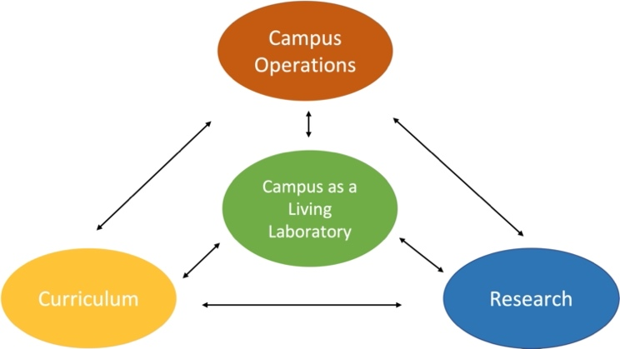

The benefits of this approach are numerous;
- Students learn better through hands-on opportunities
- Service-learning increases student satisfaction
- Using the campus as a living lab promotes civic engagement
- Efficient use of institutional resources
- Instills students with relevant skills that have real-world impact
- Provides support for operational staff for implementing certain projects
- Fosters partnerships with local businesses, non-profits and other community partners
- Fosters internal partnerships within the university

The living laboratory model has successfully been incorporated into sustainability planning at numerous other universities, where students are often involved in a range of sustainability related projects. The table below summarizes common examples of living laboratory projects from other universities.

Sustainability Goal | Example Campus Projects
Energy efficiency | - Install building sensors, monitor energy use, calculate return on investment for renewable sources
Transportation | - Develop a business plan for alternative-fuel campus fleet
Building Services | - Conduct waste inventories and improve equipment logging and tracking
Food Services | - Redesign food waste procedures for campus composting or anaerobic digestion  - Partner with campus community gardens or farms to provide local, sustainable foods in campus dining halls
Grounds | - assess campus pesticide use, and create plans for integrated pest management  - Establish formal tree care plans for campus  - Develop plans for natural area restoration projects

To an extent, NIU has already embraced the living laboratory model. For example, in spring and fall 2021, NIU students were involved in two shorelines restoration projects at NIU’s East Lagoon. This effort was a multi-year partnership between Dr. Courtney Gallaher’s environmental management class, Dr. Holly Jones’ restoration ecology class, ESE, and NIU Grounds. Students were involved in the planning, greenhouse planting, shoreline planting, and long-term evaluation of this planting process. This type of experience could easily be replicated in restoration planning for other natural areas on campus.
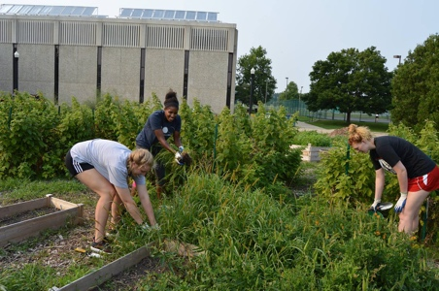
The communiversity gardens, led by Melissa Burlingame (ESE), have been used as a hands on practicum, teaching students about sustainable food systems, sustainable business practices, and community partnerships. In addition to regularly partnering with a variety of classes, the gardens have successfully partnered with other campus organizations, such as the Huskie Food Pantry, to feed our students.

In 2019, students in Dr. Gallaher’s Environmental Management class conducted a greenhouse gas inventory for the City of DeKalb in collaboration with 350Kishwaukee, a local climate action organization. Much like the process presented in this report, they learned to use the ICLEI Clearpath inventory tool, and were involved in the data collection, analysis, and presentation of results to the City of DeKalb. This project was later expanded and incorporated into a thesis project for a master’s student.
There have been numerous other students and faculty led projects related to sustainability at NIU over the years. Better aligning these efforts with formal climate action and sustainability planning at NIU will elevate these types of engagement opportunities for our students while improving the long term sustainability and resiliency of our campus. The living laboratory model also provides the framework for integrating DEI initiatives at NIU into sustainability and climate action at NIU, through applied work around environmental justice on campus.

Future greenhouse gas inventories

Include additional Scope 3 data
Several important sources of emissions were omitted from this GHG inventory, given the difficulty of obtaining accurate records at this point in time. However, they do contribute to NIU’s carbon footprint and efforts should be made to include these in future inventories. The following sources should be included in future inventories:
- Athletics travel— this includes travel that is contracted with outside companies (e.g. chartered buses, flights)
- Employee travel—any travel conducted without the use of university vehicles (e.g. travel to conferences or field sites)
- Purchased goods and services
- University investments

Accounting for purchases and investments is particularly tricky and is something that better resourced institutions of higher education still struggle to accurately account for in their greenhouse gas inventories. However, Second Nature can provide helpful guidance for how to include this in our inventory calculations.

Transportation survey
Transportation is a major source of emissions for NIU, largely because of contributions from employees and students who commute to campus. However, the methods used to estimate emissions in this sector for the 2019 and 2020 inventories required many assumptions about the commuting behaviors of employees and students. We recommend conducting a transportation survey to verify the actual commuting behaviors as this would greatly improve the accuracy of the data. ICLEI recommends a survey response rate of 20% for this type of survey. The following types of information should be included in the transportation survey:
- How many days per week do they travel to campus
- How do they get to campus (e.g. drive, bike, bus, walk, etc) and how frequently is each mode of transportation used
- Do they carpool
- What type of vehicle do they drive (passenger vehicle, light truck, etc.)
- What kind of fuel does their vehicle use (gas, diesel, electric, hybrid)

Frequency of Future Inventories
A greenhouse gas inventory should be conducted at least every 2-3 years for NIU progress can be benchmarked made against our initial GHG inventories in 2019 and 2020. Given the time consuming nature of conducting a full GHG inventory, and the relatively large contributions of the transportation and energy sectors, it would be acceptable to inventory only these sectors more frequently and complete a full inventory less regularly.

Streamline data collection process
Collecting data for a campus greenhouse gas inventory is time and labor intensive, but there are ways to streamline the data collection that would enable this to be completed more frequently. Based on our experiences with the 2019/2020 inventories, we recommend the following:
- Collaborate with DOIT and the offices who house the data to identify ways to automate the data collection process. For example, per our request, DOIT has agreed to redesign part of Accounts Payable’s new OnBase system that will be used to collect faculty and staff travel reimbursement requests in such a way that it will easily output the data needed to include this information in Scope 3 of future GHG inventories.
- Designate specific staff members in relevant offices as responsible for providing the data an on annual or biannual basis
- Determine the frequency of greenhouse gas inventories that will be needed to adequately track NIU’s progress. It is possible to track only the major sources of emissions (energy and transportation) more frequently, and the other sources less regularly without significantly impacting the overall results.

Choice of inventory tool
The 2019 and 2020 inventories were compiled using ICLEI’s Clearpath tool. This choice was made based on prior familiarity with the tool and ICLEI’s reputation as an organization with a long history of work in this area. However, many universities now use the SIMAP tool. This tool integrates seamlessly with the AASHE STARS reporting tool, as well as with Second Nature. Given NIU’s intention to obtain AASHE STARS certification and our recommendation that NIU become a signatory to Second Nature’s carbon commitment, we recommend future inventories be conducted using the SIMAP tool.

Acknowledgements

The greenhouse gas inventories and report were completed by Courtney Gallaher (Campus Sustainability Coordinator), Emely Hernandez Yac (graduate assistant), and Jim Fitzjarrell (Architecture and Engineering Services). We appreciate the cooperation and assistance that was given to us from the campus and community stakeholders below.

Appendices

Appendix A. Global Warming Potential (GWP) values for IPCC’s 5th assessment

Gas | 5th assessment 100-yr | 5th assessment 20-yr
CO₂ | 1 | 1
CH₄ | 28 | 84
N₂O | 265 | 264
SF₆ | 23,500 | 17,500
HFC-23 | 12,400 | 10,800

Appendix B. Climate Commitments made by peer and regional institutions

Institution | Climate Leadership Network  Membership Type | Race to Zero Member | Carbon Neutral Date
Indiana State University | Carbon | Yes | 2050
University of New Hampshire | Climate | No | 80% by 2050
University of Wisconsin- Milwaukee | Climate | No | Unknown
University of North Carolina- Charlotte | Carbon | Yes | 2050
Auburn University | Carbon | Yes | 2050
Ohio University | Carbon | No | 2075
San Diego State | Carbon | Yes | 2050
Northern Arizona University | Carbon | Yes | Unknown
University of Wisconsin- Whitewater | Climate | Yes | 2050
University of Wisconsin- Madison | Resilience | No | Unknown
University of Minnesota- Twin Cities | Carbon | Yes | 2050
St. Cloud State (MN) | Carbon | Yes | 2035
University of Minnesota- Duluth | Carbon | Yes | 2050
Western Michigan | Climate | No | 2065
University of Toledo | Carbon | No | 2058

Source: Second Nature Climate Leadership Network Map

Appendix C. Examples of climate action planning initiatives at other universities

Energy
- Prioritize energy conservation measures
- Retrofit energy systems in buildings
- Installation of renewable energy sources for on-site energy generation (e.g. solar panels)
- Purchase of renewable energy credits (RECs)
- Create a revolving fund, where cost savings from energy efficiency are reinvested in new energy projects

Transportation
- Incentivize carpool/rideshare programs for staff and students
- Support work-from-home policies
- Institutionalize bicycle parking and planning
- Implement bike sharing programs
- Invest in electric vehicle charging stations
- Convert the university fleet to electric vehicles

Off-setting and downstream emissions
- Require carbon offsets for all university related air travel
- Purchase carbon offsets, as needed, until other measures are implemented to reach goal of net zero
- Divest university investments from support of fossil fuel industries
- Prioritize sustainability in all purchasing and contracts

Climate Resilience
- Improve campus flood mitigation strategies
- Develop plans for increased disruptions due to extreme heat, cold, and/or severe and hazardous weather events
- Increase engagement with surrounding communities
- Support initiatives to improve student and community health measures

Natural resources, ecosystem services, and waste management
- Reduce water use, such as through low flow fixtures
- Invest in natural habitat restoration
- Create a tree care plan for campus
- Develop zero waste plans
- Reduce food waste and other waste on campus

Education
- Integrate climate change and carbon neutrality into curriculum across campus
- Increase the number of students majoring in sustainability related majors, minors, and certificates
- Incentivize and reward research related to climate science, climate policy, environmental justice, and related disciplines

Bibliography

IPCC, 2018: Global warming of 1.5°C. An IPCC Special Report on the impacts of global warming of 1.5°C above pre-industrial levels and related global greenhouse gas emission pathways, in the context of strengthening the global response to the threat of climate change, sustainable development, and efforts to eradicate poverty [V. Masson-Delmotte, P. Zhai, H. O. Pörtner, D. Roberts, J. Skea, P.R. Shukla, A. Pirani, W. Moufouma-Okia, C. Péan, R. Pidcock, S. Connors, J. B. R. Matthews, Y. Chen, X. Zhou, M. I. Gomis, E. Lonnoy, T. Maycock, M. Tignor, T. Waterfield (eds.)]. In Press.

IPCC, 2021: Climate Change 2021: The Physical Science Basis. Contribution of Working Group I to the Sixth Assessment Report of the Intergovernmental Panel on Climate Change [Masson-Delmotte, V., P. Zhai, A. Pirani, S.L. Connors, C. Péan, S. Berger, N. Caud, Y. Chen, L. Goldfarb, M.I. Gomis, M. Huang, K. Leitzell, E. Lonnoy, J.B.R. Matthews, T.K. Maycock, T. Waterfield, O. Yelekçi, R. Yu, and B. Zhou (eds.)]. Cambridge University Press. In Press.

Le Quéré, C., Jackson, R.B., Jones, M.W. et al. Temporary reduction in daily global CO₂ emissions during the COVID-19 forced confinement. Nature Climate Change. 10, 647–653 (2020). https://doi.org/10.1038/s41558-020-0797-x

Ranganathan, J., Corbier, L., Schmitz, S., Oren, K., Dawson, B., Spannagle, M., Bp, M. M., Boileau, P., Canada, E., Frederick, R., Vanderborght, B., Thomson, H. F., Kitamura, K., Woo, C. M., Naseem, &, Kpmg, P., Miner, R., Pricewaterhousecoopers, L. S., Koch, J., … Camobreco, V. (2004). GHG Protocol Initiative Team World Business Council for Sustainable Development Pankaj Bhatia World Resources Institute World Business Council for Sustainable Development Peter Gage World Resources Institute Revision Working Group Core Advisors.

Wuebbles, D., J. Angel, K. Petersen, and A.M. Lemke (Eds.), 2021: An Assessment of the Impacts of Climate Change in Illinois. The Nature Conservancy, Illinois, https://doi.org/10.13012/ B2IDB-1260194_V1.

